OPEN SOURCE GRAPHICS
AND
ANIMATION TOOLS

Mid sem
(Superman clipart)

Submitted to:
Dr. Durgansh Sharma

Submitted by:
Harsh Raj
Roll no: 82
Sap ID: 500070787

B. Tech CSE (OSOS)
COMPUTER SCIENCE & ENGINEERING

School of Computer Science
University of Petroleum and Energy Studies,
Dehradun – 248007: Uttarakhand

STEP 1: Select a picture to draw.
STEP 2: Open GIMP.
STEP 3: Create a new file Size: A3
STEP 4: Draw the outline of Cartoon with the help brush or pencil tool.
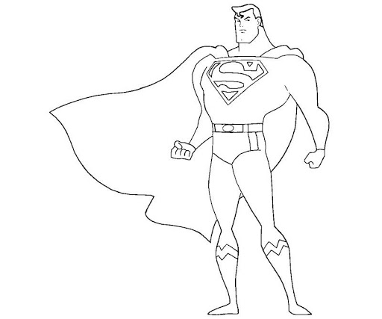
STEP 5: After completion of outline then select that part using selection tool and make it a new layer.
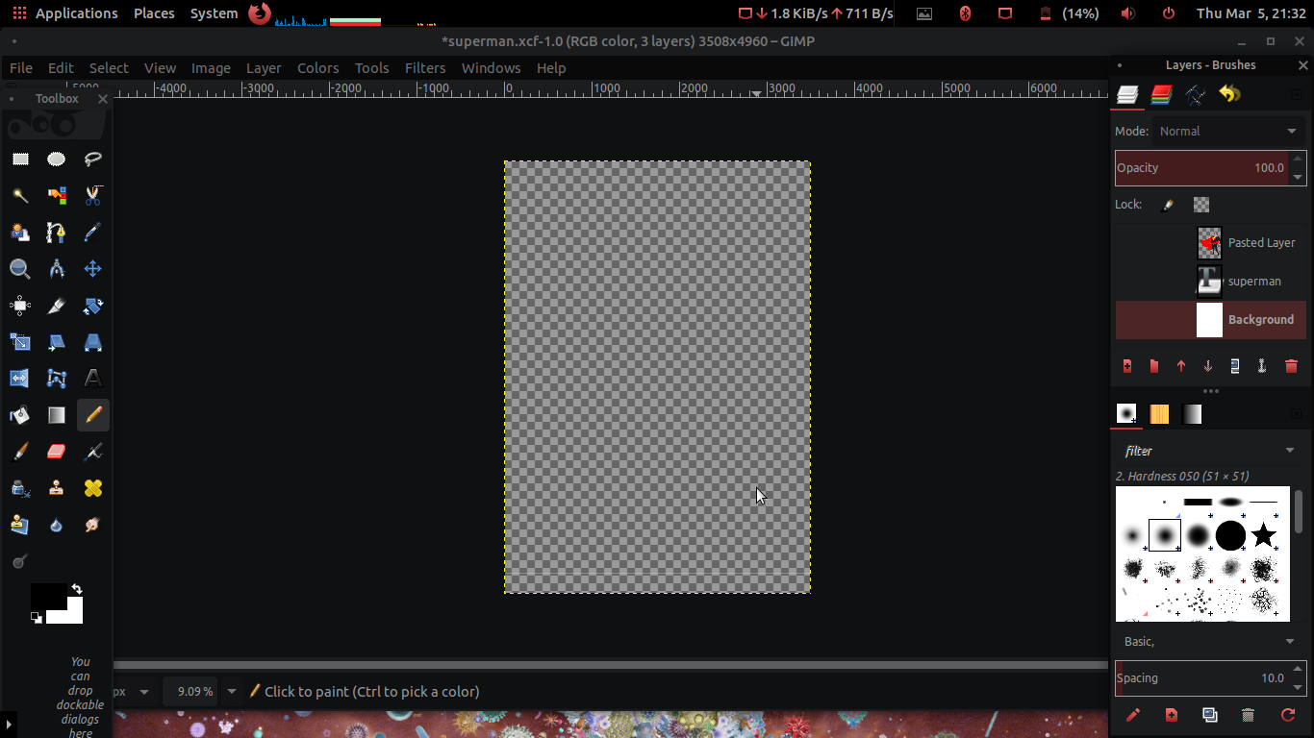
STEP 6: Then adjust it's size using scale layer option.
STEP 7: Then make inner outline of that player and wicktets using pen or pencil.
STEP 8: Using Fuzzy Selection tool select the area which I want to fill, then select color for that area in color management and fill it with the help of bucket fill.
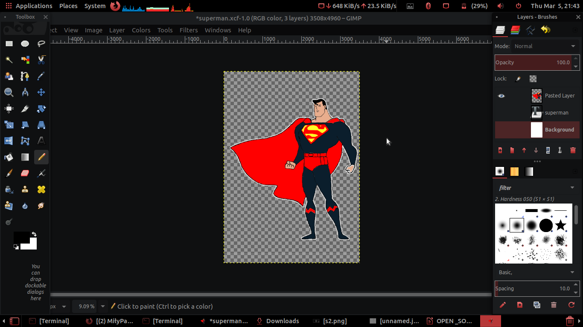
STEP 9: Then Select Background layer and with the help of brush/pencil tool fill the background color.
STEP 10: Select Eraser tool and go to the brush style tool bar and select the design look like cloud and then erase some portion of background with the help of eraser.
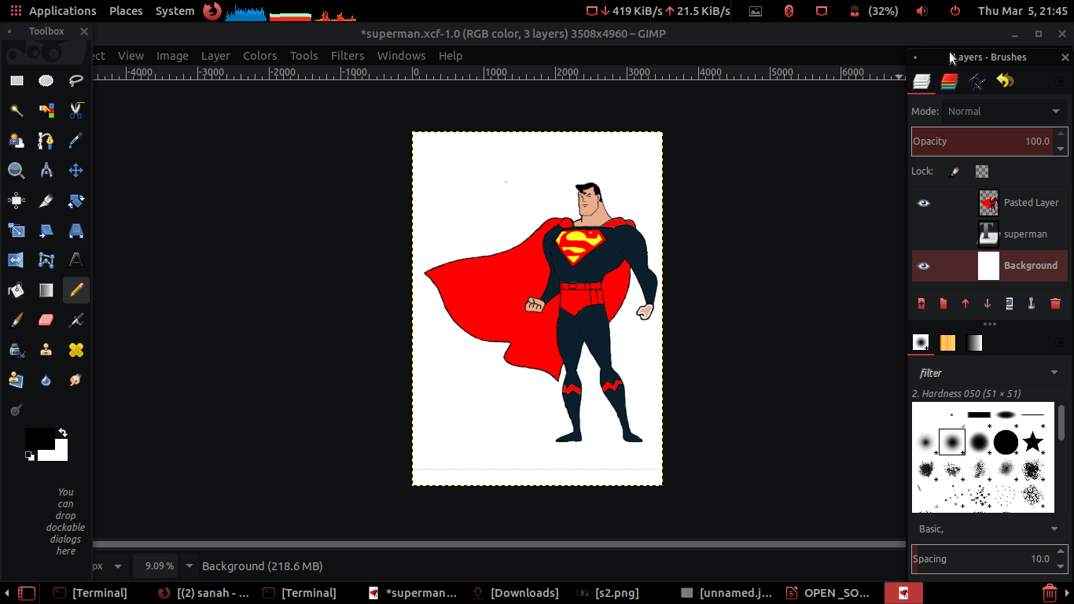
STEP 11: Now pick the Text Tool and select the area to write, and write superman on top of the Image.
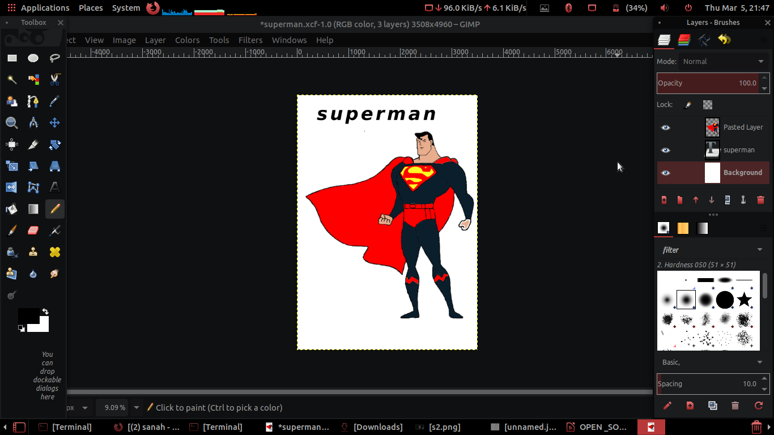
STEP 12: Then adjust its Kerning, Baselin, Spacing and select Italic, bold and its font (Sans Bold Italic).
STEP 13: Go to Image option in menu bar then Select flattern image option for combine all Layers.
STEP 14: To save as PNG format: go to file option in menu bar. Then select Export option then save it as a PNG format. Then save it.

Text Typefaces details:-
Kerning: 4.7
Spacing: 10.0
Basline: 76.0
Font: Sans Bold Italic

##I take a Help in outlines of characters from Real Picture with the help of Fuzzy Tool and Select by Color Tools. ##

IMAGE:

